AN ACT TO ADOPT ORDINANCE 2023-0001 PROPOSING THE ANNEXATION OF TERRITORY CONTIGUOUS TO THE TOWN OF FRANKFORD

WHEREAS, pursuant to the Town of Frankford Charter Section 40, the Town Council has the authority to annex any territory contiguous to the Town by complying with the procedures set forth in Section 40, in addition to the requirements for annexation in Title 22 of the Delaware Code; and
WHEREAS, pursuant to Section 40(A) of the Town Charter, The Bernard P. Lynch Trust is the owner of three contiguous parcels-To Wit, Tax Parcel Nos.: 433-6.00-1.00; 433-6.00-1.01 and 433-6.10-13.00 and the owner has requested annexation pursuant to a written request dated April 22, 2022; and
WHEREAS, the Town Council within 180 days following the filing of said Petition voted to accept such Petition on or about May 2, 2022; and
WHEREAS, pursuant to Section 40 (A)(l), the Town Council 1s required to introduce an Ordinance proposing the annexation of such territory contiguous to the Town;

NOW, THEREFORE, the Town of Frankford hereby adopts Ordinance 2023-0001 proposing the annexation of said parcels which sets forth the proposed annexation as follows:
- The parcels to be annexed are Tax Parcel Nos.: 4.33-6.00-1.00; 433- 6.00-1.01 and 4.33-6.10-13.00.
- The reasons for the proposed annexation are:

  - The proposed annexation is consistent with the Town's Comprehensive Plan;
  - The proposed annexation will provide additional tax revenue for the Town;
  - The proposed annexation will extend the Town's boundaries; and
  - The proposed annexation will attract new businesses within the Town limits.
- The proposed zoning for this parcel is Residential.

- The proposed annexation meets all of the requirements for annexation in Title 22 of the Delaware Code.
ADOPTED BY COUNCIL THIS 6th DAY OF February,2023.

(SEAL)

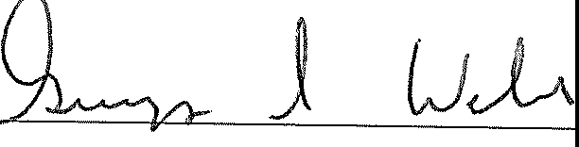
PRESIDENT OF THE TOWN OFFRANKFORD

